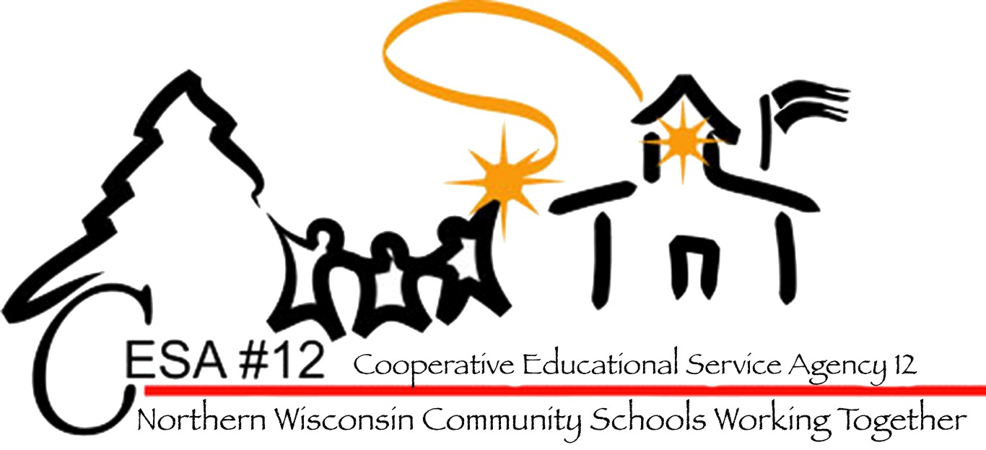
July 29-30, 2014
Lakewoods Resort,Cable, WI

August 5 & 6, 2015
Flat Creek Conference Center
Hayward, WI
Northern Wisconsin Special Education Conference 2015
Hosted by the
CESA 12
Center for Students with Disabilities
www.cesa12.org

Wednesday & Thursday, August 5 & 6, 2015

Schedule and Session Descriptions
Day One August 5, 2015
8:30 Welcome Jerianne Kvapil Rosin, Director of SPED, CESA #12
9:00-10:30 Keynote Presentation: Co-Teaching
Tracy Elger, Director of Programs and Services, CESA #2
10:30-10:45 Break
10:45-12:00 Co-Teaching Tracy Elger, Director of Programs and Services, CESA #2
12:00-1:00 Lunch
1:00-2:15 Alternative Programing Beth Lewis, Department of Public Instruction
2:15-2:30 Break
2:30-3:45 What Kids with Emotional or Behavioral Disorders Really Need Hugh Davis, WI Family Ties

Day Two August 6, 2015

9:00-10:30 Keynote Presentation: Functional Behavior Assessment
John Bemis, Wisconsin Department of Public Instruction
10:30-10:45 Break
10:45-12:00 Functional Behavior Assessment John Bemis, Wisconsin DPI
12:00-1:00 Lunch
1:00-2:15 Shortened Day Marge Resan, Wisconsin Department of Public Instruction
2:15-2:30 Break
2:30-3:45 Transition Assessment Kathy Tuttle, Transition improvement Grant Coordinator

Registration Fee:
Day 1, August 5, Only: $150
Day 2, August 6, Only: $150
BOTH Days, August 5 & 6: $250

To register go to: www.myquickreg.com
**NOTE: Be sure to mark in the “Notes” section of your registration when you will be attending. This will determine your registration fee.
Questions: Contact Sue Erickson suee@cesa12.org 715-682-2363 X135

